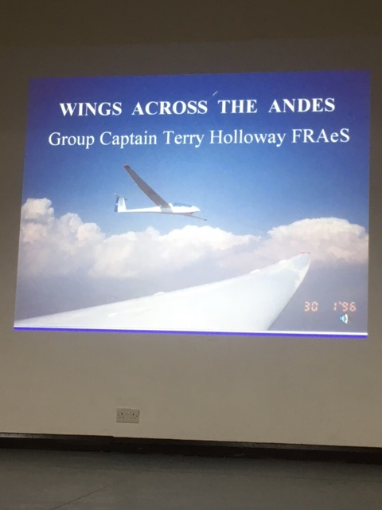

Below is a a selection of photos used by Terry Holloway – at the Martlesham Heath Aviation Society Meeting. Friday 5th April 2024

Terry’s introduction to gliding, as a teenager, was flights in gliders like this tandem T31 Glider, (flown by many Air Cadets between 1951 and 1986) – and flown from Martlesham Heath until the Airfield here was abandoned in 1963. Terry flew from Christchurch and other airfields like Bicester.

Terry mentioned that the Germans were not allowed to operate military aircraft between the wars – but , as war looked increasingly likely encouraged teenagers to fly in similar Gliders. They also flew in Gliders like the one below…..

Gliders like this were also flown by the RAF Air Cadets, and for Glider enthusiasts in this country.

The Glider became very useful in the 2nd World War, with the germans (for instance) using small trrop carrying Gliders to bypass the Belgian defences – crossing canals that were one of their chief defence lines.

Terry then went on to talk about modern gliders and how sophisticated they have become.

The ultimate modern Glider is the one above.

Terry had always had an ambition to fly a glider over the highest mountain in Chile, Mount Aconagua…. which is 21,000 feet tall.

The Chilean Airforce was looking for some newgliders – so Terry had a look around, and using his contacts managed to source 5 Cessna C172 Gliders, for around £70,000 each. If he wanted new ones they would cost about £270,000 each.

So the adventure started.

They already had very close contacts with the Chilean Air Force.

So Terry and his team of RAF pilots went with the Gliders to train them on the new gliders.

Above is a picture of the RAF and Chilean Airforce teams involved in this new project. They flew from a Chilean Air Force station at Santiago, the Gliders being towed launched by a Cessna *Bird Dog* light aircraft.

Below is a picture of what it is like to fly high over the Andes. It is not easy to fly Gliders in this area, as Thermals (used to get the Gliders to extreme heights) are very unpredictable. Terry said there are about 253 missing planes that have crashed somewhere in the Andes range.

The terrain is fascinating – below is part of the mountain range, the orange coloring being due to the high prevalance of copper in the mountain. Chile is a major exporter of copper .

After some practice flights the 5 Gliders with mixed RAF and Chilean Air Force Crews got use to flying in the unforgiving terrain

At last success. Because of the hirght that all had to wear ozygen masks – and take special precautions to avoid frost-bite. The could not take sandwiches with them – as the temperature dtopped to about C -40 degrees. They warded off altitude sicknes by drinking lots of CoCo Tea!

A party then followed:

Terry, with the audience enthralled – them went on to talk about some other aircraft adventures.

On leaving the R.A.F he went, as Engineering Officer to Marshall’s Aerospace at Cambridge Airfield. He still works for them – but not full time.

Despite being ground based he has managed to have flights in a Lightning and Hawker Hunter Fighter, as well as taking the control in Carolyn Grace’s 2 seat Spitfire, as well as DeHavilland *Tiger Moths. For many years he owned a De Havilland “Hornet Moth”.*

He has now totalled flying in well over 200 different aircraft.

The Evening was truly fascinating – and we look forward to keeping up our contact with Terry.

END OF REPORT